1. **Go through the code**

# 1D grid definition **usually do not change**

line x location=0.0 spacing=1<nm> tag=SiTop

line x location=20<nm> spacing=2<nm>

line x location=100<nm> spacing=10<nm>

line x location=600<nm> spacing=20<nm>

line x location=1<um> spacing=50<nm>

line x location=4<um> spacing=0.2<um> tag=SiBottom

# Initial simulation domain **usually do not change**

region Silicon xlo=SiTop xhi=SiBottom

# Initialize the simulation

init field=Phosphorus concentration=1e15<cm-3> resistivity=5 wafer.orient=100

# Setting for automatic meshing **usually do not change**

mgoals min.normal.size=3<nm> max.lateral.size=0.2<um> normal.growth.ratio=1.4

# Blanket implant **the implantation format is below**

# implant species=Phosphorus Silicon

implant Phosphorus energy=150<keV> dose=1.5e13<cm-2> gaussian

# **Output diffusion profile of the dopant, legend name is “Phosphorus_Implant”, file name is “blanket_PImplant”**

SetPlxList {Phosphorus_Implant}

WritePlx blanket_PImplant.plx

# field oxide **Oxidation, including ramping up and down**

diffuse temperature=800<C> time=20<min> ramprate=10<C/min>

diffuse temperature=1000<C> time=10<min> O2

diffuse temperature=1000<C> time=100<min> O2

diffuse temperature=1000<C> time=35<min> ramprate=-5.714<C/min>

# P-well Activation **Diffusion. The gas is N2, which means no oxidation**

diffuse temperature=1000<C> time=300<min> N2

# Deposit Polysilicon

deposit poly type=anisotropic thickness=200<nm> temperature=560<C>

# P-Dope Implant **Implant another dopant, boron**

implant BF2 energy=50<keV> dose=5.0e14<cm-2> gaussian

# **Output diffusion profile file**

SetPlxList {Boron_Implant}

WritePlx pdope_BImplant.plx

# Final Anneal

diffuse temperature=950<C> time=30<min> N2

# **Output sheet resistance of each layer, in this case they are polysilicon and silicon**

layers

SheetResistance

# **Output the combined diffusion profile file of the two dopants above, which are phosphorus and boron**

SetPlxList {PTotal BTotal}

WritePlx total.plx

1. The diffusion profile files and a log file will be generated after your simulation is done

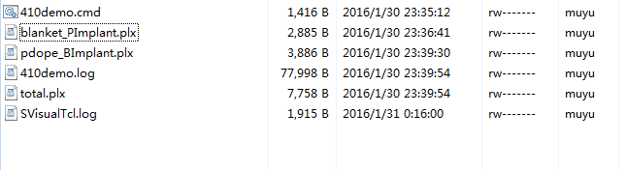

**In the command window, type in “svisual total.plx”, the diffusion profile can be extracted:**

**Red is phosphorus, green is boron!!!!! In this curve you can get the diffusion profile for each kind of dopants, segregation effect at the boundary between poly/oxide or oxide/Si (think about it why!!) The precise poly/oxide thickness, sheet resistance can be obtained directly from the .log file.**

